Seasonal temperature and flow drive population dynamics in a native salmonid

Yoichiro Kanno^{* a}, Benjamin H. Letcher ^{b}, Nathaniel P. Hitt ^{c}, Elise F. Zipkin ^{d}, and David A. Boughton ^{e}
ª School of Agricultural, Forest, and Environmental Sciences, Clemson University, Clemson, SC, USA
^{b} Silvio O. Conte Anadromous Fish Research Center, United States Geological Survey, Turners Falls, MA, USA
^{c} Leetown Science Center, United States Geological Survey, Kearneysville, WV, USA
^{d} Department of Zoology, Michigan State University, East Lansing, MI, USA
^{e} Southwest Fisheries Science Center, National Oceanic and Atmospheric Administration, La Jolla, CA, USA
* Corresponding author: ykanno@clemson.edu

Summary

- Animal populations are characterized by demographic heterogeneity among space, time and individuals. Environmental change affects population dynamics via the complex interactions with this heterogeneity.

- We investigated effects of air temperature and flow during fall, winter and spring on survival and recruitment of brook trout (Salvelinus fontinalis) by applying a multi-state population model to a 15-year fish count record collected from 72 sites in Shenandoah National Park, Virginia, USA.

- Total population size across study sites neither increased nor decreased, but it fluctuated over time particularly for young-of-year (YOY) fish. Demographic rates often responded differently to the same environmental condition. In particular, YOY and adult survival rates responded differently to flow conditions during all seasons. Low fall flow and high winter flow were the most deleterious seasonal climate conditions to brook trout populations.

- Under simulated deleterious seasonal conditions, brook trout populations persisted and recovered quickly as long as deleterious conditions occurred infrequently (< every 5 years) due to heterogeneous responses of different demographic rates and density-dependent per capita recruitment. High-elevation sites were less susceptible to population declines due to higher adult survival rates, providing a mechanistic explanation on how brook trout populations persist better in these sites under climate change.

- Our analysis demonstrated that spatial, seasonal and size-dependent heterogeneity in demographic rates may be inferred based exclusively on unmarked data. Pathways of climate change impact on brook trout populations are complex, but it needs to be accounted for conservation of this cold-water salmonid particularly at the southern range.

Key-words climate change, hierarchical models, Salvelinus fontinalis, stock-recruitment relationship, streams, survival

Introduction

Climate influences vital population rates and this is the mechanism through which species range and abundance will be affected by climate change (Wright et al. 2009; Hegel et al. 2010; Nilsson et al. 2011). Understanding climate effects on population vital rates is a pre-requisite to an accurate assessment of animal responses to future climate change. Research on climate-animal relationships should incorporate seasonal effects on vital rates because an alteration of a key environmental (e.g. temperature increase) may have different effects on vital rates during different seasons and a net effect on population growth is not apparent by assessing a single season (Diamond et al. 2013; Dybala et al. 2013). Assessing through the annual cycle indeed reveals important seasonal drivers of population dynamics (Wright et al. 2009; Fernández-Chacón et al. 2011). Knowledge on seasonal effects requires long-term data sets, which are few in animal population studies.
Studying seasonal climate influences on animal populations is further complicated by several reasons. First, demographic parameters typically differ along environmental gradients (Letcher et al. 2007; Jenouvrier et al. 2009). This suggests that the impact of climate drivers varies over space (Fernández-Chacón et al. 2011) and understanding such spatial heterogeneity is much needed for conservation planning. Second, different life stages of a population respond differently to the same climate condition. It is typical that survival rates vary among size classes in the same environment (Diamond et al. 2013; Dybala et al. 2013). Finally, animal populations are regulated by density-dependent factors, as well as density-independent (environmental) factors. Density-dependence has been observed in recruitment (Diamond et al. 2013) and survival (Lok et al. 2013) in animal populations, and the strength of density-dependence affects the population stability and resiliency (Lack 1954).
These issues pose a difficult challenge in designing and analysing survey data of animal populations, particularly for cryptic species in which individual detection is far from perfect and vital rates are hard to observe. Mark-recapture methods have been most commonly employed in inferring demographic rates (Williams, Nichols & Conroy 2002). A caveat of mark-recapture studies is that their expensive and labour-intensive nature does not typically allow for conducting fieldwork at a number of sites. Recording animal counts is less labour-intensive and it allows the researcher to collect spatially and temporally replicated data. But count data are considered to contain more sparse information on demographic rates and they have been used less frequently in demographic analysis of animal populations (e.g. Gross, Craig & Hutchison 2002; Link, Royle & Hatfield 2003). However, the recent advance in analysis of unmarked data may provide a promising approach to understanding seasonal climate effects on population dynamics. Dail & Madsen (2011) proposed a statistical approach that models apparent survival and recruitment rates based on count data replicated over space and time. This method was further extended by Zipkin et al. (2014) who demonstrated that demographic heterogeneity among stages (e.g. age, size and sex) could be modelled in the Dail-Madsen framework. This type of multi-state population models can potentially provide a flexible framework in which temporal and spatial heterogeneity in the environment as well as density-dependent processes are effectively incorporated in the analysis of unmarked data.
In this study, we investigated effects of air temperature and stream flow during fall, winter and spring on survival and recruitment of brook trout (Salvelinus fontinalis Mitchill) using a 15-year fish count record collected from 72 sites in Shenandoah National Park, Virginia, U.S. Stream temperature and flow are the key drivers of fish population dynamics (Poff et al. 1997; Arismendi et al. 2013), and numerous studies have shown that stream fish populations are affected by average and extreme conditions of these key environmental covariates (e.g. Roghair, Dolloff & Underwood 2002; Perry & Bond 2009; Xu, Letcher & Nislow 2010a). Stream temperature and flow will be affected by climate change via alterations in air temperature and precipitation regimes (Novotny & Stefan 2007; Huntington et al. 2009). Consequently, there is a great need for understanding temperature and flow effects on population dynamics of stream fish, particularly for southern populations of a coldwater species such as brook trout.
Our objectives were two-fold. The first objective was to develop a multi-state population model to assess the effects of seasonal temperature and flow on demographic rates while accounting for variation among size classes and space, and density-dependence in recruitment. The majority of previous stream fish studies focused on the effects of summer conditions on demographic rates (Boss & Richardson 2002; Xu, Letcher & Nislow 2010a), and much less is known about other seasons (e.g. Jensen & Johnsen 1999; Berger & Gresswell 2009). Our second objective was to use the multi-state model to explore the effect of deleterious seasons and years in simulations. We sought to understand brook trout population responses to extreme climate events because the frequency and magnitude of such events are projected to increase under climate change (Rummukainen 2013). By addressing the two study objectives, we demonstrate the utility of spatially and temporally replicated animal abundance data (without mark-recapture data) in understanding key seasonal effects on population vital rates and abundance.

Materials and methods

STUDY SPECIES
The brook trout is native to north-eastern North America, ranging from Georgia, U.S. to Labrador and Quebec, Canada. They inhabit clear and cold waters, and stream temperature is a major factor affecting their distribution and abundance (Hartman & Cox 2008; McKenna & Johnson 2011). Stream flow has also been shown to affect brook trout populations (Roghair, Dolloff & Underwood 2002; Xu, Letcher & Nislow 2010a).
Brook trout populations have declined greatly due to a combination of anthropogenic activities, particularly at the southern range where they currently occur at high-elevation streams along the Appalachian Mountains (Hudy et al. 2008). Brook trout in headwater streams are typically short-lived (< 3-4 years old) and can reproduce at small body size (< 100 mm) (Grossman et al. 2010; Xu, Letcher & Nislow 2010b; Kanno et al. 2012). Brook trout spawn during autumn and females excavate small depressions called “redds” in which fertilized eggs remain until late winter to early spring. A majority of body growth takes place during spring (March-June) in a stream located at the northern portion of the U.S. range (Xu, Letcher & Nislow 2010b). Microhabitat preferences change through ontogeny. Young-of-year (YOY) individuals that are < 1 year old are more common in tributaries and at shallow depths, but larger trout prefer deeper and slower sections of streams such as pools (Kanno et al. 2012; Anglin & Grossman 2013).

FISH DATA
We used a portion of a long-term monitoring data set collected by the National Park Service during 1996-2010 at 72 sites in the Shenandoah National Park, Virginia, USA (Fig. 1). The study area lies within the Blue Ridge physiographic region represented by steep slopes, narrow ridges and high relief. Elevation of 72 sites ranged from 285 to 802 m (median = 436 m). Sites are located on small headwater streams (first- to third-order) that are well-shaded by riparian vegetation and are generally characterized with step-pool or cascade habitats. Stream flow typically peaks in spring followed by low-flow conditions in late summer to fall. Study sites typically harbour few fish species and common species include blacknose dace (Rhinichthys atratulus), mottled sculpin (Cottus bairdi) and fantail darter (Etheostoma flabellare).
Each study site was approximately 100 m in stream length. Upstream and downstream ends of sites were typically bounded by natural geomorphic habitat breaks that impede fish movement (e.g. step pools), and they were marked permanently on the stream bank. Brook trout were surveyed between May and August (mostly June to August) during 1996-2010. Only two out of 72 sites were surveyed annually during the 15-year study period, and as few as three visits were made at 15 sites. As a result, the data set contained missing occasions and this is typical of long-term ecological data collected at multiple sites.
Consistent field protocols using backpack electrofishing were applied to standardize sampling effort across study sites. Three-pass depletion surveys were conducted to infer fish capture probabilities on most sampling occasions (84 %, or 514 out of 611 occasions), but single-pass surveys were conducted otherwise. Fish movement in and out of sites were prevented because most site boundaries coincided with natural geomorphic breaks and they were supplemented by constructing cobble dams. Block nets were used when this approach was not successful. The number of electrofishers used depended on stream width and it ranged 1-3 electrofishers among sites. Each electrofisher was accompanied by two netters and sampling crews proceeded upstream by sampling all available habitats carefully. Captured fish were measured for total length (± 1 mm) and weight (± 0.1 g), and returned to the stream alive. YOY individuals can be distinguished from older individuals (“adults” hereafter) based on length-frequency distributions in brook trout populations (Xu, Letcher & Nislow 2010b; Kanno et al. in press), and this was also the case for brook trout populations in Shenandoah National Park. Thus, fish count data were available by site, year, fish size (YOY or adults) and electrofishing pass.

TEMPERATURE AND FLOW DATA
We characterized seasonal mean air temperature and stream flow conditions experienced by the study area. Seasons were defined as fall (September-November), winter (December-February) and spring (March-May). Summer temperature and flow were not characterized because this is the period in which fish surveys took place (see above). We used air temperature and stream flow data from a single location in the Shenandoah National Park by assuming that they represent regional environmental conditions and can adequately characterize temporal variation in climate.
Air temperature data at the Shenandoah National Park (38º5333´ N, 78º3500´ W) were derived from the Daymet database (http://daymet.ornl.gov). The Daymet model generates long-term daily maximum and minimum air temperature values at the resolution of 1 km². We used daily maximum air temperature values to calculate seasonal mean maximum air temperature (hereafter ‘seasonal air temperature’). Stream flow data were derived from a gaging station maintained by the National Park Service as part of the Shenandoah Watershed Study program (http://swas.evsc.virginia.edu/). The gaging station was in the White Oak Run located at the southern part of the Shenandoah National Park (Fig. 1). Seasonal mean discharge was calculated from daily discharge values.

STATISTICAL ANALYSIS
We examined the effects of seasonal temperature and flow on demographic rates by using a state-structured open population N-mixture model (Zipkin et al. 2014). Classic N-mixture models estimate population abundance at a set of local sites over a time period in which the total population is assumed to be closed (Royle 2004). Abundance estimates are made possible by employing a repeated sampling scheme that infers the capture probability of individuals. Dail & Madsen (2011) extended N-mixture models to open populations in which the population size changes over time due to a survival process and a “gains” process (recruitment and immigration). Their approach has been further extended for more ecologically realistic situations in which individual heterogeneity within a population, as represented by size, age or sex, is accounted for (Zipkin et al. 2014). This model provides inferences on state-specific vital rates as well as abundance estimates.

Brook trout life cycle
We assumed an annual population model of brook trout in the Shenandoah National Park comprised of two age classes; YOY and adults (Fig. 2). A portion of YOY individuals at a local site survive annually and transition into the adult class. Those adults that survive remain in the same state. YOY and adults experience different annual survival probabilities, as represented by ω₁ (YOY) and ω₂ (adults) in the life cycle diagram (Fig. 2). Survival of brook trout typically differs by body size in other populations (Petty, Lamothe & Mazik 2005; Letcher et al. 2007). Brook trout mature at a small body size (< 100 mm, Hudy et al. 2010; Kanno, Vokoun & Letcher 2011) and we assumed that adults are capable of reproducing offspring. We assumed that sites were independent of each other. It should be stressed that we did not specifically model immigration and emigration based on the assumption of no net dispersal in and out of a local site. This was a plausible assumption because a local site was established at a representative section of a stream, and therefore we did not consider that the local site did not differ greatly from adjacent stream sections. Immigration can be specifically modelled in the state-structured open population N-mixture model (Zipkin et al. 2014), but we found that the inference on immigration term is highly sensitive to a slight change in model specifications in our data set as well as simulations (Y. Kanno & D.A. Boughton, unpublished data).

Modelling variation in abundance
We defined our count data, y_{i,t,j,k}, as the observed count of individuals at site i in year t for age class j and electrofishing pass k. Our main interest was to infer demographic rates that govern the spatial and temporal variation in N_{i,t,j}, the true age-specific abundance for each site and year. The population abundance for YOY (j = 1) and adults (j = 2) in the first year of sampling was assumed to follow a Poisson distribution such that N_{i,1,j} ~ Poisson(λ_{j}) for all sampling sites {i = 1,…,72}. In subsequent years (t ≥ 2), population size was modelled by demographic processes according to the life cycle of the brook trout population (Fig. 2). Specifically, all individuals of YOY and adults that survived an annual time step were assumed to transition to the adult class. We considered a binomial survival process in which survival probabilities (ω) differ by site, year and age class, and adult abundance represented a sum of surviving individuals from both age classes such that:
S_{i,t-1,1} ~ Binomial(N_{i,t-1,1}, ω_{i,t-1,1})
S_{i,t-1,2} ~ Binomial(N_{i,t-1,2}, ω_{i,t-1,2})
N_{i,t,2} = S_{i,t-1,1} + S_{i,t-1,2}
where S_{i,t-1,j} denotes the number of individuals in age class j at site i that survive from year t–1 to year t. Recruitment was similarly modelled as a Markovian process. We assumed that recruitment to the YOY class depended on local adult abundance in the previous year such that:
N_{i,t,1} ~ Poisson(γ_{i,t,}* N_{i,t-1,2})
where γ_{i,t} was the per capita recruitment rate which varied by site and year.

Adding temporal and spatial covariates
We further modelled the effects of spatial and temporal covariates on the survival probabilities and recruitment rate using appropriate link functions in linear models. Survival probabilities were modelled as a function of seasonal mean temperature and flow as well as local elevation using the logit link:
logit(ω_{i,t,j}) = α_{,j} + β1_{j}*(fall flow_{t}) + β2_{j}*(winter flow_{t}) +
β3_{j}*(spring flow_{t}) + β4_{j}*(spring temperature_{t}) +
β5_{j}*(elevation_{i})
where an intercept (α) and slope (β) terms are indexed by age class (j) to examine potentially heterogeneous effects of covariates for YOY versus adults. Mean fall and winter temperatures were not included in the model because fall temperature was negatively correlated with fall flow (Pearson’s r = -0.71) and winter temperature was negatively correlated with winter flow (Pearson’s r = -0.62). We dropped temperature covariates because flow varied more widely than temperature among years (Coefficient of Variation: fall flow = 0.98, winter flow = 0.76, fall temperature = 0.06, winter temperature = 0.25). We considered that the wider environmental gradient should trigger biological responses better. Covariates retained in the linear model had Pearson’s r values less than |0.42| with one another. Each covariate was standardized by subtracting its mean and dividing by its standard deviation. Fall, winter and spring flow was square-root transformed prior to standardization to improve normality.
The same set of spatial and temporal covariates was used in recruitment. In addition, we included a density-dependent recruit-spawner function using the Ricker model because a bell-curved relationship was observed in inferred yearly total abundance in which YOY abundance peaked when adult abundance in the previous year was at the intermediate range (see Results). Density-independent (environmental covariates) and density-dependent terms were related to recruitment using the log link (Maceina & Pereira 2007):
log(γ_{i,t}) = α0 – β0*N_{i,t,2} +
β1*(fall flow_{t}) + β2*(winter flow_{t}) +
β3*(spring flow_{t}) + β4*(spring temperature_{t}) +
β5*(elevation_{i})
where α0 denoted the per capita recruitment rate at low spawner abundance and β0 denoted the density-dependent coefficient.

Modelling capture probabilities
Capture probabilities of individuals were inferred based on the three-pass electrofishing data. Typically, N-mixture models use temporally repeated surveys within a closed season where the number of individuals subject to capture remains constant across repeated surveys (Royle 2004; Zipkin et al. 2014). We modified it in order to account for the depletion sampling design in which the number of individuals subject to capture decreases in successive electrofishing passes. We assumed that capture probabilities (p_{i,t,j}) are constant across passes but vary by age class and sampling occasion as such:
y_{i,t,j,1} ~ Binomial(N_{i,t,j}, p_{i,t,j})
y_{i,t,j,2} ~ Binomial(N_{i,t,j} – y_{i,t,j,1}, p_{i,t,j})
y_{i,t,j,3} ~ Binomial(N_{i,t,j} – y_{i,t,j,1} – y_{i,t,j,2}, p_{i,t,j})
where the first binomial process described how observed data for the first pass (y_{i,t,j,1}) were derived, followed by the second pass (y_{i,t,j,2}) and third pass (y_{i,t,j,3}). Furthermore, capture probabilities were modelled based on habitat characteristics of sampling occasions that were considered to affect electrofishing sampling efficiency. That is, stream size and depth (i.e. flow) are known to affect capture probabilities of fish (Falke et al. 2010; Jensen & Vokoun 2013). Stream flow data were not available for each sampling occasion and we used two covariates as surrogates for stream flow in a linear model:
logit(p_{i,t,j}) = α_{,j} + β1_{j}*(Julian date_{i,t}) + β2_{j}*(wetted width_{i,t})
where an intercept (α) and slope (β) terms are again indexed by age class (j) because electrofishing is size-selective. Julian date was used to approximate the temporal pattern of decreasing stream flow from the begging of the sampling season (May) to the end (August) observed in the study area during 1996-2010 (Appendix S1). Mean stream wetted width represented spatial variation in stream size among sample sites and it was measured on the fish sampling day at each site based on measurements at 10 evenly spaced transects that were perpendicular to stream flow. Both Julian date and wetted width were standardized again by mean divided by standard deviation.

Scenario simulations
We used the model described above in two sets of simulated environmental conditions over 30 years (twice the study period) in order to gain better understanding of our model behaviour and the potential effects of climate change manifested via alterations in temperature and flow. The first set of scenarios subjected the study populations to temporally constant environmental conditions. Specifically, for each seasonal covariate included in the model (i.e., fall flow, winter flow, spring flow and spring temperature), we defined “favourable” and “deleterious” conditions as 1.5 times standard deviation from the mean value. We ran eight simulations (four covariates times two conditions) in which the favourable or deleterious condition for a seasonal covariate persisted for 30 years after the end of our 15-year study period while the other environmental conditions were set to their mean values.
The second set of simulations represented temporally variable environmental conditions. We chose deleterious fall flow (low flow) and winter flow (high flow) conditions that impacted population abundance most negatively (see Results), and we changed the frequency of these deleterious events in simulations in order to understand how brook trout populations rebound from them. We deemed this exercise particularly informative because extreme climate events are projected to increase under climate change (Rummukainen 2013). Four temporally varying conditions were considered over the course of 30 years (after the 15-year study period); (1) deleterious fall flow occurs every five years, while the mean winter flow condition occurs in other years, (2) deleterious winter flow occurs every five years, while the mean fall flow condition occurs in other years, (3) both deleterious fall flow and winter flow condition occurs every five years (“extreme years” hereafter), while mean fall and winter flow conditions occur in other years, and (4) extreme years occur in two consecutive years, followed by three years of mean fall and winter flow conditions. In all four scenarios, other seasonal covariates were set to their mean values.

Analysis of the models
We analyzed our models with a Bayesian approach using Markov chain Monte Carlo (MCMC) methods in JAGS (Plummer 2011) called from R (R Development Core Team 2012) with the rjags package (Appendix S2 for JAGS code). Uninformative priors were used throughout, including Jeffery’s priors (mean = 0 and SD = 1.643) for the intercept and slope terms on the logit scale (i.e. survival and capture probabilities). Posterior distributions of model parameters were estimated by taking the 100th sample from 20,000 iterations of three chains after discarding 10,000 burn-in iterations. Model convergence was checked by visually examining plots of the MCMC chains for good mixture as well as the R-hat statistic. This statistic compares variance within and between chains, and models are considered to have converged when the value is less than 1.1 for all model parameters (Gelman and Hill 2007). The R-hat values were less than 1.08 for all parameters in our models. We evaluated the importance of covariates by their estimated coefficient size; covariates whose 95 % Credible Interval (95 % CI) did not overlap with a value of 0 were considered statistically significant.

Results

DEMOGRAPHIC RATES
Annual survival probability was higher for adults (0.453) than for YOY (0.319) (Table 2). While spring temperature was positively correlated with survival of both YOY (0.319) and adults (0.302), flow during all seasons affected survival of two size classes differently. Fall and spring flow had positive effects on YOY survival, but it had negative effects on adult survival (Table 2). Winter flow was the least important seasonal flow covariate on both YOY and adult survival (Table 2). Elevation had a strong positive effect on adult survival (0.342) but only a weak positive effect on YOY survival (0.078) (Table 2).
Per capita recruitment was strongly affected by fall flow (0.524) and by winter flow (-0.379) (Table 2). In addition, coefficients of the Ricker stock-recruitment model indicated the presence of density-dependence in recruitment (Table 2). YOY abundance at local sites increased with local adult abundance in the previous year when local adult abundance ranged from 0 to 50 individuals per 100 m (Fig. 4). At higher adult densities, local YOY abundance in the following year was not sensitive to adult abundance in the present year (Fig. 4).
Based on the demographic values obtained in the analysis, we ran sensitivity analyses while assuming temporal (flow and temperature) and spatial (elevation) covariates are at their mean values. Due to the density-dependent recruitment rate, we used three arbitrary values of local adult abundance in the sensitivity analysis. Three values corresponded to low local abundance (10 individuals per 100 m: 10th percentile of estimated local abundance when pooled over sites and years), median (45 individuals per 100 m: 50th percentile), and high abundance (121 individuals per 100 m: 90th percentile). In all cases, YOY survival was the most sensitive demographic parameter to the population growth rate, followed by adult survival and then by per capita recruitment (Table 3). The population growth rate (λ) was 1.15 at low abundance, 1.05 at median abundance, and 0.86 at high abundance.

CAPTURE PROBABILITIES and ABUNDANCE
Capture probability depended on trout body size and environmental conditions. Adult capture probability (0.631) was higher than YOY capture probability (0.511) (Table 2). This was an expected result because electrofishing is size selective and larger individuals are typically detected more easily. Julian date had a significantly positive effect on capture probability (0.179) (Table 2), suggesting that capture probability increases from May to August. Stream width had a significant negative effect (-0.140) (Table 2) and trout capture was more difficult in wider streams.
Annual total abundance estimated across 72 sites was generally lower for adults (mean = 4,049 individuals) than YOY (mean = 6,473) (Fig. 3). YOY abundance fluctuated over time more widely than adult abundance. Coefficient of variation was 61.1 for YOY versus 27.5 for adults. YOY and adult abundance neither increased nor decreased during the 15-year study period (Fig. 3).

SIMULATED SCENARIOS
Scenario analyses identified favourable and deleterious climate conditions, which were not immediately apparent by examining estimated demographic parameters (Table 2) because parameters often responded differently to the same environmental condition. Total population size was projected to decline at low fall flow, high winter flow and low spring temperature conditions, with the first two climate conditions exerting strong negative effects on abundance (Fig. 5). Total adult population size projected to be higher or equal to total YOY abundance in all scenarios (Fig. 5), which generally mirrors the observed adult/YOY rations between 1996 and 2010. Under favourable climate conditions, total population size across 72 sites plateaued at < 20,000 for YOY and < 15,000 for adults due to the presence of density-dependent recruitment (Fig. 4). It is noteworthy that population persistence varied spatially due to the strong positive relationship between elevation and adult survival (Table 2). Even under deleterious conditions such as low fall flow and high winter flow, high-elevation sites (> 600 m above sea level) maintained small populations (adult abundance < 50 individuals typically) during the 30-year simulation period (Fig. 6). To the contrary, low-elevation sites (< 400 m) were projected to be extirpated under constant deleterious conditions in 15 years of simulations (Year 30: Fig. 6).
Simulating temporally dynamic climate conditions highlighted the potential high degree of population resiliency in brook trout populations. When deleterious seasonal climate conditions (low fall flow or high winter flow) were projected to occur every five years followed by average conditions, population trajectories showed a stable to slightly increasing pattern over the 30-year simulation period (Fig. 7). Population size appeared to be stable and bounce back quickly when extreme years (a combination of low fall flow and high winter flow in the same year) were simulated to occur every five years (Fig. 7). The declining population trend was observed when extreme years occur for two years consecutively followed by three years of average climate conditions (Fig. 7).

Discussion

Demographic heterogeneity among space, time and individuals holds the key to a refined understanding of environmental change on animal populations, and this heterogeneity has been traditionally studied with mark-recapture models (Williams, Nichols & Conroy 2002). Our approach instead relied exclusively on unmarked individuals to reveal how temporal and spatial environmental covariates were related to size-specific survival and recruitment rate for a coldwater native salmonid for which climate change is of great concern. Our major results were: (1) various demographic rates often responded differently to the same environmental condition, (2) higher-elevation sites were less vulnerable to deleterious climate conditions due to higher adult survival rate, and (3) brook trout populations were projected to recover quickly from disturbances.
Our inferences on the effects of climate conditions agreed well with previous studies of brook trout population ecology. Low fall flow and high winter flow had strong negative impacts on abundance in Shenandoah brook trout populations. Fall flow had a major positive effect on per capita recruitment, and variable effects on survival (positive for YOY and negative for adults). Brook trout is a fall spawner and they tend to move upstream into small tributaries for spawning (Kanno, Vokoun & Letcher 2011b; Mollenhauer et al. 2013). In much of the native range of brook trout, baseflow condition (i.e. lowest stream discharge) occurs during late summer to early fall, and a positive relationship has been reported between stream discharge and spawning movement (Mollenhauer et al. 2013; Kanno et al. 2014). Thus, low fall flow may have hampered access to spawning habitats in the small and high-gradient streams in Shenandoah. To the contrary, high winter flow resulted in low population abundance. Winter floods have been related to recruitment failures in southern brook trout populations because fertilized eggs remain in the gravel during this period and they are susceptible to bed scouring (Petty, Lamothe & Mazik 2005). While fall flow had variable but sizeable effects on YOY and adult survival, winter flow had small effect sizes on survival of both size classes. Thus, the impact of high winter flow appeared to be manifested primarily via recruitment success.
The various responses of demographic rates to the same climate conditions have important ecological and conservation implications. The frequently contrasting effects on survival of YOY versus adults were particularly interesting results. Whereas spring temperature had positive effects of survival of both size classes, regression coefficients on flow had opposite directions between YOY and adults in all seasons (Table 2). Size-independent thermal responses are expected because temperature effect should be primarily physiological (Hartman & Cox 2008). Size-dependent flow effects may have resulted from ontogenetic microhabitat change common in stream salmonids. Adult brook trout tend to occupy deeper and slower habitats, where YOY prefer shallower habitats and small tributaries (Kanno et al. 2012; Anglin & Grossman 2013). We consider that asynchrony in vital rates, combined with early maturation and high fecundity, is an important reason why brook trout are surprisingly resilient to environmental disturbances and persist in small and isolated sections of temporally dynamic environments such as headwaters (Letcher et al. 2007; Kanno, Vokoun & Letcher 2011b). Another important mechanism of resiliency was density-dependent recruitment. There was a positive relationship between the number of spawners and the number of recruits in the following year only when a local spanwer population size was small (< 50 individuals per 100 m: Fig. 4). Reproductive success can be highly variable among brook trout individuals and a few adults are capable of reproducing many surviving offspring (Kanno et al. 2014). We acknowledge that demographic and genetic stochasticity should become important at very small population sizes, and we did not consider potentially deleterious effects that may arise. Still, the ability of brook trout populations to bounce back quickly from extreme environmental conditions is an important finding as the frequency and magnitude of extreme events are expected to increase under climate change.
Brook trout populations have declined particularly at the southern and central range of their native distribution and they are typically relegated to small headwater streams (Hudy et al. 2008). Climate change is projected to further restrict potential habitat of stream salmonids in smaller or higher-elevation streams because stream temperature should remain more suitable at these headwater sites (Wenger et al. 2013). Our demographic analysis similarly indicated that higher-elevation sites are more resilient to deleterious climate conditions. A new perspective offered in the current work is that the resiliency was conferred by higher survival of adults at high-elevation. This paper does not provide a mechanistic explanation of why adult survival is higher in high-elevation sites, and it remains an important question of ecological and conservation interest. Brook trout survival has been linked to environmental heterogeneity such as stream size, availability of pool habitat, stream temperature and flow (Xu, Letcher & Nislow 2010a; Kanno et al. 2014). Although adult survival was important in explaining spatial heterogeneity, we also point out that YOY survival was the most sensitive demographic rate to population growth rates in Shenandoah populations. The same conclusion has been drawn from other population studies of headwater brook trout populations (Marschall & Crowder 1996; Letcher et al. 2007) and this is common among short-lived freshwater fish species (Vélez-Espino, Fox & McLaughlin 2006). These observations suggest that early-life survival is an under-studied but important demographic rate for population dynamics and conservation of many freshwater fishes.
Long-term monitoring datasets are few in animal population ecology, and this is why monitoring designs should be thoroughly assessed when an opportunity exists to collect such datasets. An important question is the balance between spatial and temporal replicates. While only two out of 72 study sites were surveyed every year during the 15-year study period, it is worth mentioning that different groups of additional sites were surveyed in consecutive years in all yearly intervals. We consider that the judicious inclusion of consecutive years helped greatly in our inferences on temporal variation in demographic rates. In addition, a combination of single-pass (16 %) and three-pass (84 %) depletion surveys allowed us to estimate size-specific capture probability. Because electofishing is size selective, accounting for capture probabilities for YOY and adults was necessary to infer population vital rates and abundance accurately. Our work represents a case study in which missing or imperfect data, which typical of long-term datasets, did not prevent the researcher from making inferences on key demographic rates.
The current work adds to and extends a growing list of studies that attempt to make demographic estimates based on unmarked data (Link, Royle & Hatfield 203; Dail & Madsen 2011; Zipkin et al. 2014). While this type of analyses is becoming more common, some shortcomings should be noted in this study. First, we did not explicitly account for immigration and assumed no net movement in and out of a local site. Zipkin et al. (2014) used simulated datasets and an empirical data set on a highly immobile stream amphibian (northern dusky salamanders Desmognathus fuscus) to demonstrate that immigration and apparent survival could be estimated simultaneously in age- or size-structured populations. Such models did not converge or model outputs were sensitive to a slight change in model structures in brook trout (Kanno et al. 2014; this study). Second, we were not able to incorporate density-dependence in survival due to convergence issues. Survival may be density-dependent in stream salmonids (Marschall & Crowder 1995), although environmental conditions generally override density-dependence in regulating stream salmonid population dynamics (Xu, Letcher & Nislow 2010a; Lobón-Cerviá in press). We note that brook trout populations should be even more resilient to disturbances if survival were to be density-dependent. Thus, the lack of density-dependent survival should not affect our major result on quick population recoveries in brook trout. Further work is warranted to assess the utility of combining unmarked data and mark-recapture data which could allow for estimation of demographic parameters that would not have been estimated from unmarked data alone (Schaub & Abadi 2009). A successful application of such approaches will allow stronger inferences on demographic heterogeneity among space, time and individuals and lead to a better understanding of environmental changes on animal population persistence.

Acknowledgements
Virginia folks who collected data. An earlier version of this manuscript was greatly improved by constructive comments by XXX.

References
Anglin, Z.W. & Grossman, G.D. (2013) Microhabitat use by southern brook trout (Salvelinus fontinalis) in a headwater North Carolina stream. Ecology of Freshwater Fish, 22, 567-577.
Arismendi, I., Johnson, S.L., Dunham, J.B. & Haggerty, R. (2013) Descriptors of natural thermal regimes in streams and their responsiveness to change in the Pacific Northwest of North America. Freshwater Biology, 58, 880-894.
Berger, A.M. & Gresswell, R.E. (2009) Factors influencing coastal cutthroat trout (Oncorhynchus clarkii clarkii) seasonal survival rates: a spatially continuous approach within stream networks. Canadian Journal of Fisheries and Aquatic Sciences, 66, 613-632.
Boss, S.M. & Richardson, J.S (2002) Effects of food and cover on the growth, survival, and movement of cutthroat trout (Oncorhynchus clarki) in coastal streams. Canadian Journal of Fisheries and Aquatic Sciences, 59, 1044-1053.
Dail, D. & Madsen, L. (2011) Models for estimating abundance from repeated counts of an open metapopulation. Biometrics, 67, 577-587.
Diamond, S.L., Murphy, C.A. & Rose, K.A. (2013) Simulating the effects of global climate change on Atlantic croaker population dynamics in the mid-Atlantic Region. Ecological Modelling, 264, 98-114.
Dybala, K.E., Eadie, J.M., Gardali, T., Seavy, N.E. & Herzog, M.P. (2013) Projecting demographic responses to climate change: adult and juvenile survival respond differently to direct and indirect effects of weather in a passerine population. Global Change Biology, 19, 2688-2697.
Fernández-Chacón, A., Bertolero, A., Amengual, A., Tavecchia, G., Homar, V. & Oro, D. (2011) Spatial heterogeneity in the effects of climate change on the population dynamics of a Mediterranean tortoise. Global Change Biology, 17, 3075-3088.
Gross, K., Craig, B.A. & Huchison, W.D. (2002) Bayesian estimation of a demographic matrix model from stage-frequency data. Ecology, 83, 3285-3298.
Grossman, G.D., Ratajczak, R.E., Wagner, C.M. & Petty, J.T. (2010) Dynamics and regulation of the southern brook trout (Salvelinus fontinalis) population in an Appalachian stream. Freshwater Biology, 55, 1494-1508.
Hartman, K.J. & Cox, M.K. (2008) Refinement and testing of a brook trout bioenergetics model. Transactions of the American Fisheries Society, 137, 357-363.
Hegel, T.M., Mysterud, A., Ergon, T., Loe, L.E., Huettmann, F. & Stenseth, N.C. (2010) Seasonal effects of Pacific-based climate on recruitment in a predator-limited large herbivore. Journal of Animal Ecology, 79, 471-482.
Hudy, M., Thieling, T.M., Gillespie, N. & Smith, E.P. (2008) Distribution, status, and land use characteristics of subwatersheds within the native range of brook trout in the eastern United States. North American Journal of Fisheries Management, 28, 1069-1085.
Hudy, M., Coombs, J.A., Nislow, K.H. & Letcher, B.H. (2010) Dispersal and within-stream spatial population structure of brook trout revealed by pedigree reconstruction. Transactions of the American Fisheries Society, 139, 1276-1287.
Huntington, T.G., Richardson, A.D., McGuire, K.J. & Hayhoe, K. (2009) Climate and hydrological changes in the northeastern United States: recent trends and implications for forested and aquatic ecosystems. Canadian Journal of Forest Research, 39, 199-212.
Jenouvrier, S., Thibault, J.C., Viallefont, A., Vidals, P., Ristow, D., Mougin, J.L., Brichetti, P., Borg, J.J. & Bretagnolle, V. (2009) Global climate patterns explain range-wide synchrony in survival of a migratory bird. Global Change Biology, 15, 268-279.
Jensen, A.J. Johnsen, B.O. (1999) The functional relationship between peak spring floods and survival and growth of juvenile Atlantic salmon (Salmo salar) and brown trout (Salmo trutta). Functional Ecology, 13, 778-785.
Kanno, Y., Vokoun, J.C. & Letcher, B.H. (2011a) Sibship reconstruction for inferring mating systems, dispersal and effective population size in headwater brook trout (Salvelinus fontinalis) populations. Conservation Genetics, 12, 619-628.
Kanno, Y., Vokoun, J.C. & Letcher, B.H. (2011b) Fine-scale population structure and riverscape genetics of brook trout (Salvelinus fontinalis) distributed continuously along headwater channel networks. Molecular Ecology, 20, 3711-3729.
Kanno, Y., Vokoun, J.C., Holsinger, K.E. & Letcher, B.H. (2012) Estimating size-specific brook trout abundance in continuously sampled headwater streams using Bayesian mixed models with zero inflation and overdispersion. Ecology of Freshwater Fish, 21, 404-419.
Kanno, Y., Letcher, B.H., Vokoun, J.C. & Zipkin, E.F. (in press) Spatial variability in survival of adult brook trout within two intensively surveyed headwater stream networks. Canadian Journal of Fisheries and Aquatic Sciences.
Lack, D. (1954) The Natural Regulation of Animal Numbers. Clarendon Press, Oxford, UK.
Letcher, B.H., Nislow, K.H., Coombs, J.A., O’Donnell, M.J. & Dubreuil, T.L. (2007) Population response to habitat fragmentation in a stream-dwelling brook trout population. PLoS One, 2(11), e1139.
Link, W.A., Royle, J.A. & Hatfield, J.S. (2003) Demographic analysis from summaries of an age-structured population. Biometrics, 59, 778-785.
Lobón-Cerviá, J. (in press) Recruitment and survival rate variability in fish populations: density-dependent regulation or further evidence of environmental determinants. Canadian Journal of Fisheries and Aquatic Sciences
Lok, T., Overdijk, O., Tinbergen, J.M. & Piersma, T. (2013) Seasonal variation in density dependence in age-specific survival of a long-distance migrant. Ecology, 94, 2358-2369.
Maceina, M.J. & Pereira, D.L. (2007) Recruitment. Analysis and Interpretation of Freshwater Fisheries Data, 1st edn (eds C.S. Guy & M.L. Brown), pp. 121–185. American Fisheries Society, Bethesda, Maryland, USA.
Marschall, E.A. & Crowder, L.B. (2011) Density-dependent survival as a function of size in juvenile salmonids in streams. Canadian Journal of Fisheries and Aquatic Sciences, 52, 136-140.
McKenna, J.E., Jr. & Johnson, J.H. (1995) Landscape models of brook trout abundance and distribution in lotic habitat with field validation. North American Journal of Fisheries Management, 31, 742-756.
Mollenhauer, R., Wagner, T., Kepler, M.V. & Sweka, J.A. (2013) Fall and early winter movement and habitat use of wild brook trout. Transactions of the American Fisheries Society, 142, 1167-1178.
Nilsson, A.L.K., Knudsen, E., Jerstad, K., Røstad, O.W., Walseng, B., Slagsvold, T. & Stenseth, N.C. (2011) Climate effects on population fluctuations of the white-throated dipper Cinclus cinclus. Journal of Animal Ecology, 80, 235-243.
Novotny, E.V. & Stefan, H.G. (2007) Stream flow in Minnesota: indicator of climate change. Journal of Hydrology, 334, 319-333.
Perry, G.L.W. & Bond, N.R. (2009) Spatially explicit modelling of habitat dynamics and fish populations persistence in an intermittent lowland stream. Ecological Applications, 19, 731-746.
Petty, J.T., Lamothe, P.J. & Mazik, P.M. (2005) Spatial and seasonal dynamics of brook trout populations inhabiting a central Appalachian watershed. Transactions of the American Fisheries Society, 134, 572-587.
Poff, N.L., Allan, J.D., Bain, M.B., Karr, J.R., Prestegaard, K.L., Richter. B.D, Sparks, R.E. & Stromberg, J.C. (1997) The natural flow regime: a new paradigm for river conservation and restoration. BioScience, 47, 769-784.
Roghair, C.N., Dolloff, C.A. & Underwood, M.K. (2002) Response of a brook trout population and instream habitat to a catastrophic flood and debris flow. Transactions of the American Fisheries Society, 131, 718-730.
Royle, J.A. (2004) N-mixture models for estimating population size from spatially replicated counts. Biometrics, 60, 108-115.
Rummukainen, M. (2013) Climate change: changing means and changing extremes. Climatic Change, 121, 3-13.
Schaub, M. & Abadi, F. (2011) Integrated population models: a novel analysis framework for deeper insights into population dynamics. Journal of Ornithology, 152 (Supplement), 227-237.
Vélez-Espino, L.A., Fox, M.G. & McLaughlin, R.L. (2006) Characterization of elasticity patterns of North American freshwater fishes. Canadian Journal of Fisheries and Aquatic Sciences, 63, 2050-2066.
Williams, B.K., Nichols, J.D. & Conroy, M.J. (2002) Analysis and Management of Animal Populations. Academic Press, San Diego, California, USA.
Wright, L.J., Hoblyn, R.A., Green, R.E., Bowden, C.G.R., Mallord, J.W., Sutherland, W.J. & Dolman, P.M. (2009) Importance of climatic and environmental change in the demography of a multi-brooded passerine, the woodlark Lullula arborea. Journal of Animal Ecology, 78, 1191-1202.
Xu, C., Letcher, B.H. & Nislow, K.H. (2010a) Size-dependent survival of brook trout Salvelinus fontinalis in summer: effects of water temperature and stream flow. Journal of Fish Biology, 76, 2342-2369.
Xu, C., Letcher, B.H. & Nislow, K.H. (2010b) Context-specific influence of water temperature on brook trout growth rates in the field. Freshwater Biology, 55, 2253-2264.
Zipkin, E.F., Thorson, J.T., See, K., Lynch, H.J., Grant, E.H.C., Kanno, Y., Chandler, R.B., Letcher, B.H., Royle, J.A. (2014) Modeling structured population dynamics using data from unmarked individuals. Ecology, 95, 22-29.

Supporting Information
The following Supporting Information is available for this article online.

Appendix S1. May to August stream flow
Appendix S2. JAGS code

Table 1. Summary of seasonal environmental covariates.
 | Median | Range
fall flow (m³/s) | 0.0475 | 0.0003-0.1842
winter flow (m³/s) | 0.0485 | 0.0003-0.1870
spring flow (m³/s) | 0.0542 | 0.0127-0.1668
fall temperature (°C) | 18.7 | 17.4-20.9
winter temperature (°C) | 7.5 | 3.6-10.0
spring temperature (°C) | 17.9 | 15.6-20.0

Table 2. Parameter estimates from the model. JAGS code can be found in Appendix S2.
 | Parameters | Names in JAGS code | Median values (95 % CI)
YOY survival
 | mean survival probability | omega.mean[1] | 0.319 (0.311, 0.327)
 | fall flow | omega.b[1,1] | 0.283 (0.216, 0.354)
 | winter flow | omega.b[1,2] | -0.085 (-0.138, -0.041)
 | spring flow | omega.b[1,3] | 0.121 (0.080, 0.169)
 | spring temperature | omega.b[1,4] | 0.349 (0.309, 0.395)
 | Elevation | omega.b[1,5] | 0.078 (0.047, 0.110)
Adult survival
 | mean survival probability | omega.mean[1] | 0.453 (0.441, 0.465)
 | fall flow | omega.b[1,1] | -0.237 (-0.284, -0.186)
 | winter flow | omega.b[1,2] | 0.141 (0.068, 0.205)
 | spring flow | omega.b[1,3] | -0.374 (-0.430, -0.324)
 | spring temperature | omega.b[1,4] | 0.302 (0.251, 0.360)
 | Elevation | omega.b[1,5] | 0.342 (0.304, 0.381)
Per capita recruitment
 | fall flow | gamma.b[1] | 0.524 (0.510, 0.537)
 | winter flow | gamma.b[2] | -0.379 (-0.394, -0.364)
 | spring flow | gamma.b[3] | -0.005 (-0.022, 0.010)
 | spring temperature | gamma.b[4] | -0.154 (-0.166, -0.141)
 | elevation | gamma.b[5] | -0.075 (-0.087, -0.065)
Ricker stock-recruitment relationship
Alpha |  | alpha | 1.002 (0.969, 1.034)
Beta |  | beta | 0.0075 (0.0071, 0.0078)
Detection probability
 | mean detection probability of YOY | p.mean[1] | 0.511 (0.505, 0.519)
 | mean detection probability of adults | p.mean[2] | 0.631 (0.624, 0.639)
 | Julian date | p.b[1] | 0.179 (0.159, 0.199)
 | Stream width | p.b[2] | -0.140 (-0.159, -0.119)
Initial abundance (first year)
 | Abundance of YOY | lambda[1] | 38.1 (36.2, 40.2)
 | Abundance of adults | lambda[2] | 47.7 (45.6, 49.8)

Table 3. Sensitivity values of demographic rates at three levels of adult local abundance; low (10 individuals per 100 m), median (45 individuals) and high (121 individuals).
 | Local abundance
 | Low | Median | High
Per capita recruitment | 0.172 | 0.195 | 0.252
YOY survival | 1.364 | 1.186 | 0.867
Adult survival | 0.622 | 0.638 | 0.679

Figure captions

Fig. 1 Map of the Shenandoah National Park (shaded by green) showing fish survey locations (brown circles). Streams are shown in blue lines.

Fig. 2 Annual life cycle of brook trout populations represented by young-of-year (YOY) and adult age classes. Demographic rates are denoted by ω₁ (YOY survival probability), ω₂ (adult survival probability), and γ (per-capita recruitment rate).

Fig. 3 Mean (95% CI) estimated annual total abundance during 1996-2010.

Fig. 4 Spanwer-recruit relationship at local sites. All years are pooled. The grey band represents a 95% CI range of the inferred Ricker curve in the model.

Fig. 5 Simulated total abundance trajectories over 72 sites under constant seasonal environmental conditions. Mean and 95% CI are shown. The first 15 years are estimated total abundance based on observed data (1996-2010) followed by 30 years of simulations.

Fig. 6 Spatial variation in abundance trajectories under “deleterious” constant seasonal environmental conditions. Each line represents mean estimated abundance at each of the 72 sites. Sites were classified as high elevation (> 600 m), mid elevation (400-600 m) and low elevation (< 400 m).

Fig. 7 Simulated total abundance trajectories under temporally varying environmental conditions.
Fig. 1.

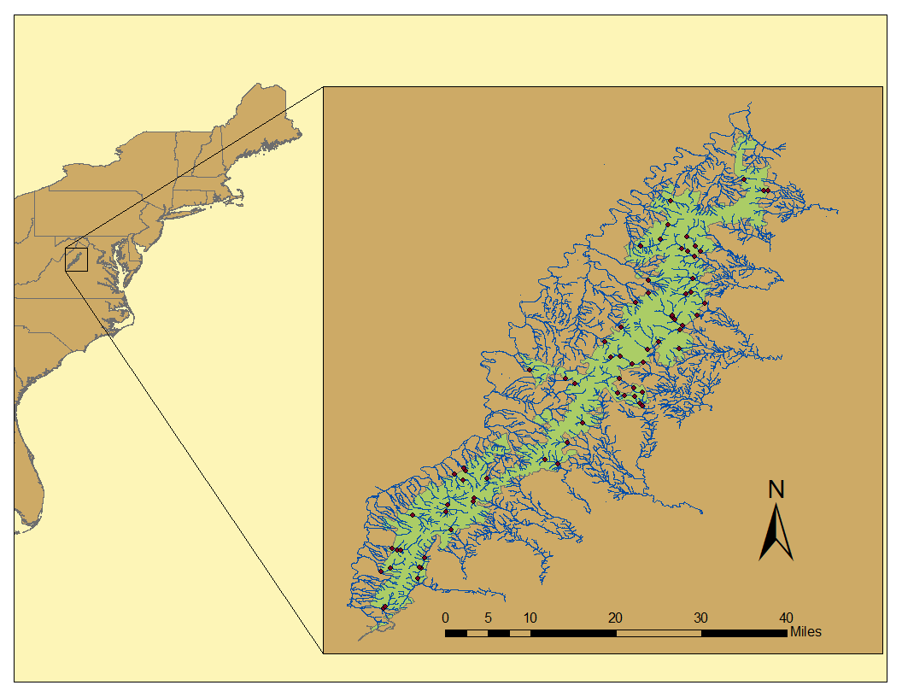

Fig. 2.

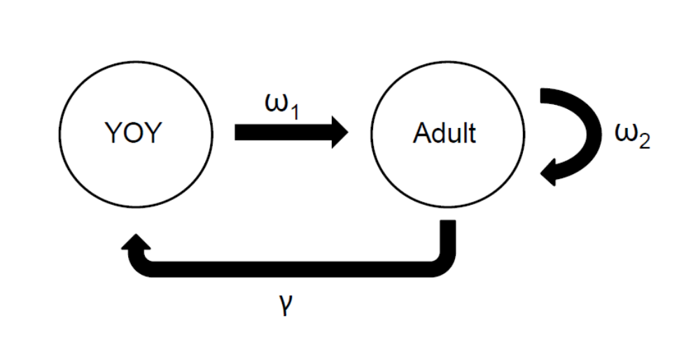
Fig. 3.

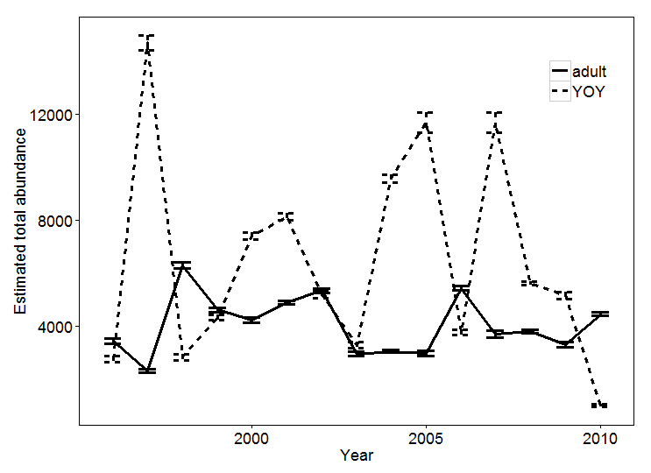

Fig. 4.

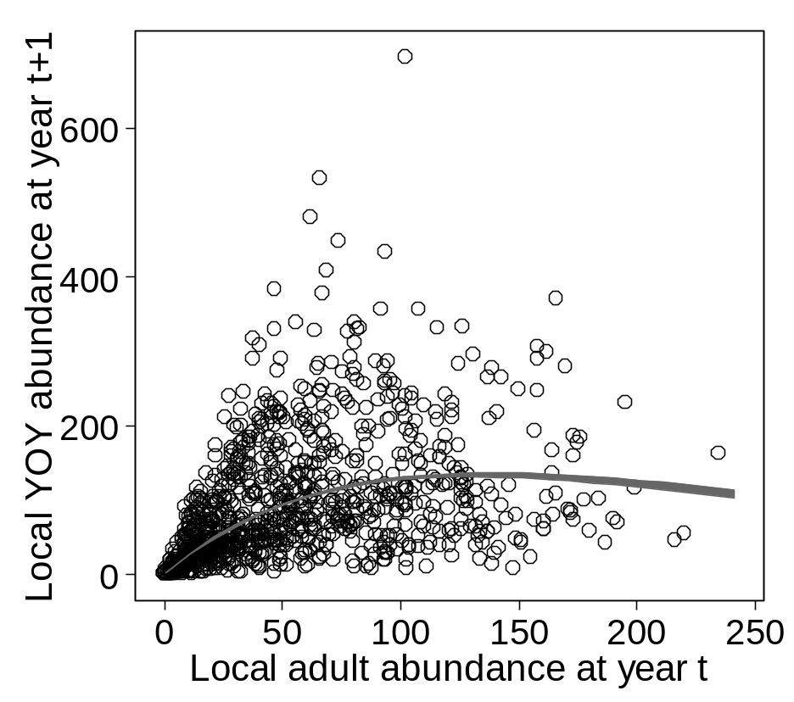

Fig. 5.

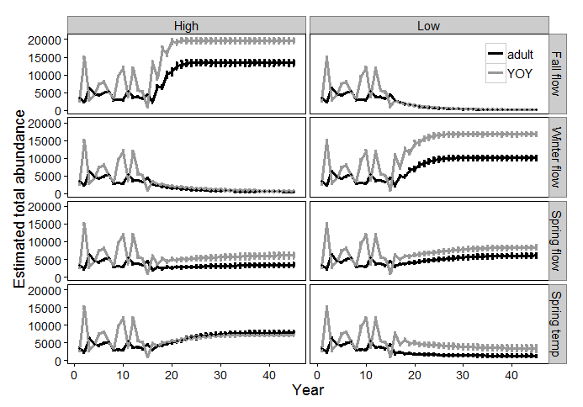

Fig. 6.
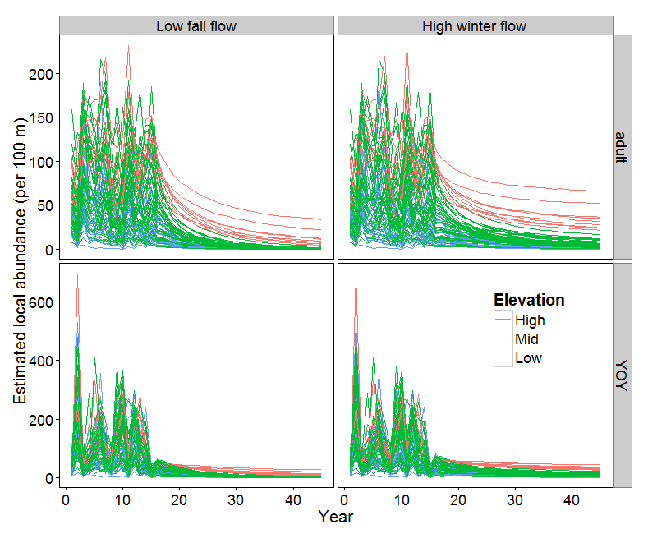

Fig. 7.

